|  |  |  |
| --- | --- | --- |
| CAPACITY BUILDING  for Curricula Modernization of  Syrian and Lebanese HEIs  &  Lifelong Learning Provision  598318-EPP-1-2018-1-LB-EPPKA2-CBHE-JP  Erasmus+ KA2 – Capacity Building in the field of Higher Education    TOWARDS  SUSTAINABLE NGOs  MANAGEMENT & OPERATION  WITH SPECIAL FOCUS ON REFUGEES (MORALE) |  | download**C:\Users\b.rg.rhatab\AppData\Local\Microsoft\Windows\Temporary Internet Files\Content.Outlook\52XB8EYS\logo Final morale.png** |
|  |
| ***Disclaimer****:*  *This project has been funded with support from the European Commission. This publication reflects the views only of the authors and the Commission cannot be held responsible for any use which may be made of the information contained therein. Reproduction is authorised provided the source is acknowledged* | |

|  |  |
| --- | --- |
| about **MORALE**  **Morale Project i**s a structural project co-funded by the ERASMUS+ Programme of the European Union.  It aims at building the capacities of Syrian & Lebanese Higher Education Institutions (HEIs) to train a new generation of high skilled professionals in Non-Governmental Organizations (NGOs) management & operation to enhance inclusion of refugees and the rebuilding of the South Mediterranean society.  **MORALE** Objectives**:**   * To provide the NGOs labour market sector with high skilled professionals trained to effectively manage and operate in NGO environments by means of modernising Social & Behavioural Sciences related curricula, and by offering lifelong courses targeting NGOs professionals in partner universities. * To raise the awareness on the key role of HE in the provision of high-level competences of the future NGOs professionals and strengthen inter-institutional cooperation among HEIs, NGOs and governments through targeted networking actions. |  |

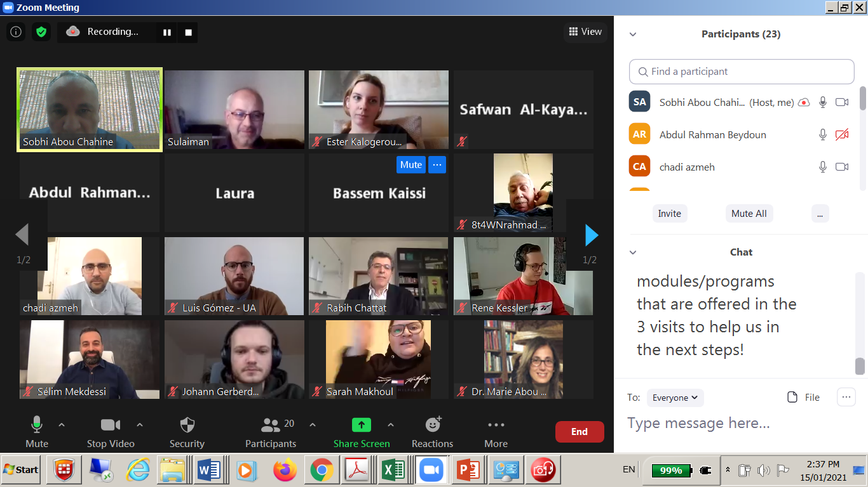

|  |
| --- |
| **Consortium Virtual Meeting off the MORALE Project**  598318-EPP-1-2018-1-LB-EPPKA2-CBHE-JP  “Capacity building for curricula modernization of Syrian and Lebanese HEIs and lifelong learning provision: towards sustainable NGOs management and operation with special focus on refugees/Morale.”  co-funded by the Erasmus+ Programme of the European Union and coordinated by the Beirut Arab University.  A Consortium Meeting off the MORALE Erasmus+ has been conducted on January 15th, 2021 through ZOOM technique with the participation of. all consortium partners, sharing and exposure to Study Visits Regional Report, In-depth needs analysis report , finalizing the strategies for WP3 (capacity building), WP4 (Curricular enhancement), WP5 (LLL) , as well as to the Intermediate report preparation. |

|  |  |
| --- | --- |
|  |  |
| |  | | --- | | **During the meeting**  At the beginning of the meeting, Dr. Soubhi welcomed partners and thanked them for their commitment and attendance of the meeting.  Then, Dr. Azmeh from IUST, summarized through a power point presentation the three visits to the universities of Bolognia, Alicante and Oldenburg. He briefly mentioned the content of each study visit and the topics covered and how they contribute to next packages.  Later on, Dr. Mouselli from AIU, requested preparing a comparison table for the modules programs related to NGO’s management at these three universities. Dr. Sobhi requested the 3 EU partners to send him as much information on available modules programs to help in formulating the content of the intended module.  Dr. Mekdissi from LU, presented the content of the report using power point presentation starting from the survey tools and the number of respondents to questionnaires and the number of conducted interviews. Then, he summarizes the recommendations for the next work packages: 4 different modules for capacity building (Training of Trainers), the main area for curricular enhancements and lifelong learning. |     **http://www.moraleproject.org/** | |  | | --- | |  | |
| Finally, the partners agreed on the following:   * Finalize the strategies of WP3, WP4, and WP5 in 10 days and hold a meeting to discuss them on the 25th January. * Select the training modules by EU partners. * Fix the dates of the training. * Fix the dates of the round tables.   Two round tables will be organized in Lebanon and Syria, End of January. |

|  |  |  |  |  |  |  |  |  |  |  |  |  |  |  |  |  |  |  |  |  |  |  |
| --- | --- | --- | --- | --- | --- | --- | --- | --- | --- | --- | --- | --- | --- | --- | --- | --- | --- | --- | --- | --- | --- | --- |
| **CONTACT US**  **MORALE PROJECT**  **Prof. Sobhi Abou Chahine**  **Dean of Student Affairs**  **Coordinator of MORALE projec**t at  **Beirut Arab University (BAU) Beirut Campus, Main Building, 3rd Floor**  **Phone: +961 1 300 110 - Ext. 2234 – 2258**  **Fax: +961 1 704 613**  **achahine@bau.edu.lb**  **rana.hatab@bau.edu.lb** <http://www.moraleproject.org/>  <http://www.facebook.com/Morale.Project/> | |  |  |  | | --- | --- | --- | | https://iconnect.bau.edu.lb/custom/mss/new_templates/BAU%20Logos/2_A5%20BAU%20Administrative%20Logo_Blue.png | C:\Users\b.rg.mkassar\Desktop\Untitled223.png | Lebanese University | |  |  |  | | C:\Users\b.rg.mkassar\AppData\Local\Microsoft\Windows\Temporary Internet Files\Content.Word\logo.png | Resultado de imagen de university of alicante logo | C:\Users\b.rg.mkassar\AppData\Local\Microsoft\Windows\Temporary Internet Files\Content.Word\uniol_kmp_2f_cmyk.tif | |  |  |  | | C:\Users\b.rg.mkassar\AppData\Local\Microsoft\Windows\Temporary Internet Files\Content.Word\unibo-logo-big.png | C:\Users\b.rg.mkassar\AppData\Local\Microsoft\Windows\Temporary Internet Files\Content.Word\4-elements.png | C:\Users\b.rg.rhatab\AppData\Local\Microsoft\Windows\Temporary Internet Files\Content.Outlook\52XB8EYS\IMG-20200731-WA0004.jpg | |  |  |  | |  | cid:M39JjajdUWn6QdRk3ect | C:\Users\b.rg.mkassar\AppData\Local\Microsoft\Windows\Temporary Internet Files\Content.Word\Alrashied logo.jpg | |