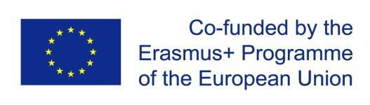

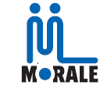

Capacity building for curricula modernization of Syrian and Lebanese HEIs and lifelong learning provision: towards sustainable NGOs management and operation with special focus on refugees

**Morale Erasmus+ Project**

598318-EPP-1-2018-1-LB-EPPKA2-CBHE-JP

|  |  |  |  |
| --- | --- | --- | --- |
| **Title** | **Zoom Consortium Meeting of**  **MORALE** | **Date** | **26 May 2021** |
| **Place** | **Virtual** | **Time** | **6:00 pm Beirut Time** |

**Attendees:** Sobhi Abou Shahin(BAU), Bassem EL Kaissi(MUBS), Selim Mekdessi(LU), Marie Aboujaoude(LU), Sulaiman Mouselli (AIU), Chadi Azmeh (IUST), Mhd Saeed Barazi (Bilad Acham University), Rabih Chattat(UNIBO), Luis Gómez de Membrillera (University of Alicante), Ester M. Kalogeroudi 4-elements (NGO), Ahmad Fayez Altabba’ (Bilad Acham University), Jorge Gomez, Laura Sadowski ( Oldenburg University), Anmar Orabi (DU), Firas hmadeh (Alrashid association)