**Steering committee virtual meeting**

May 13th 2020

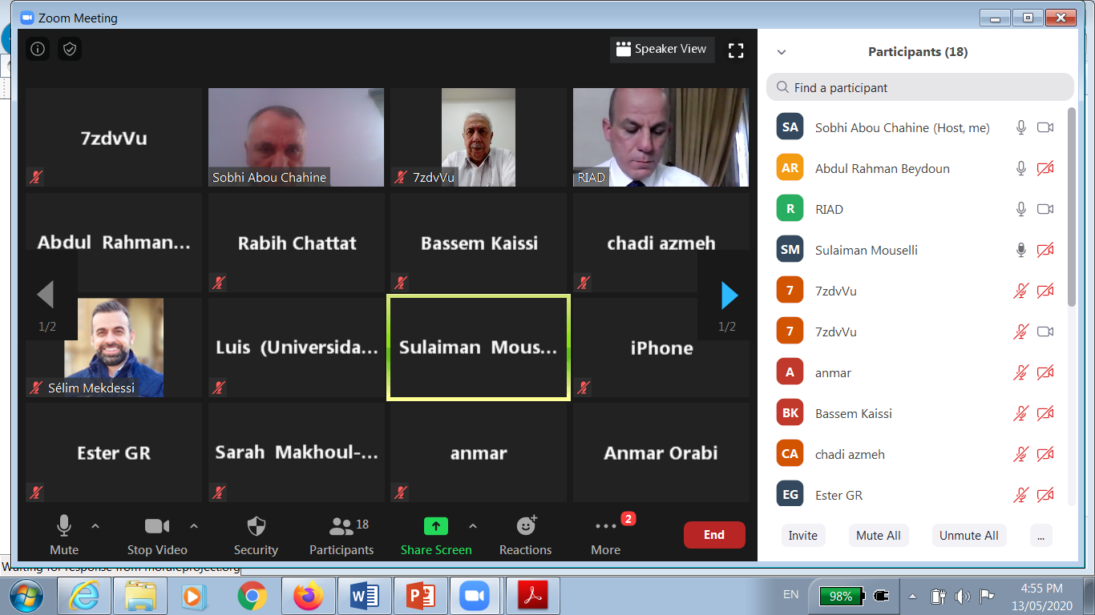

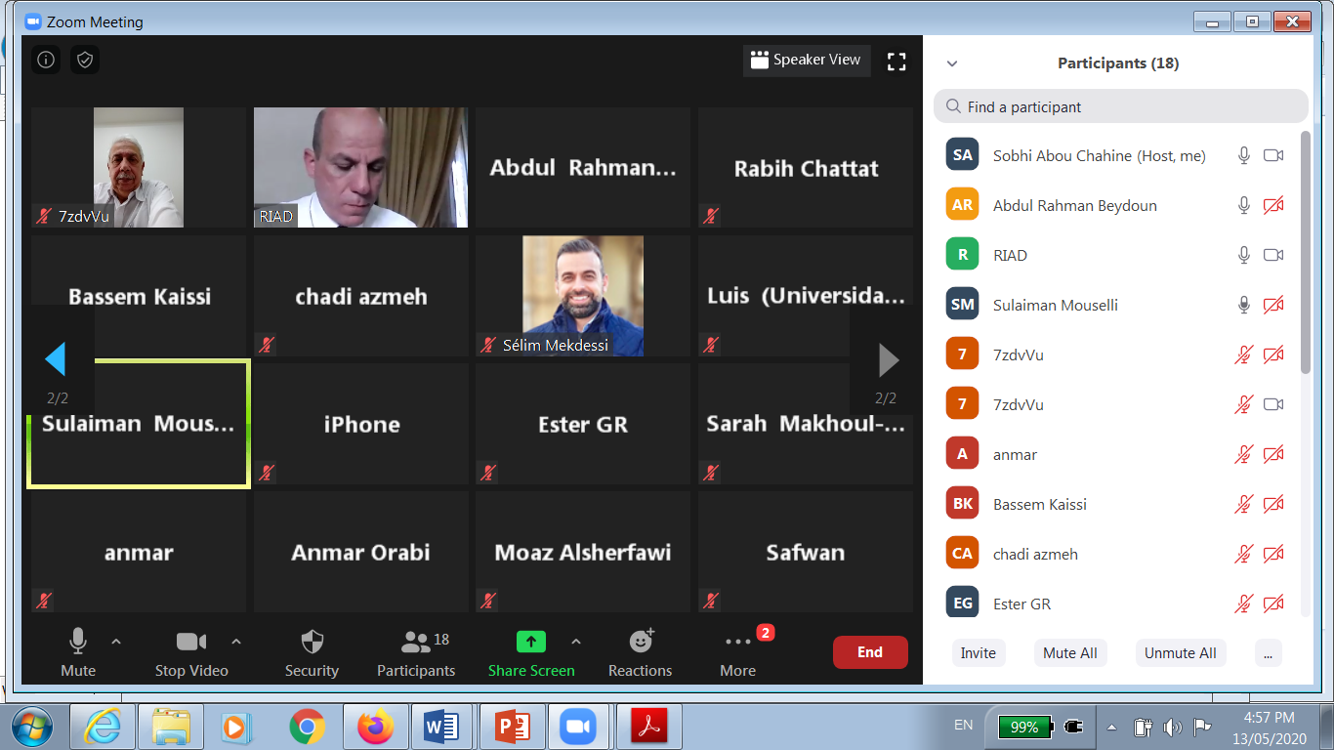

Due to the current situation with Coronavirus (COVID-19), and to avoid any delay in the implementation of the project activities, a virtual meeting of the Morale Erasmus+ steering committee was organized via Zoom technology with the participation of all partners on May 13th 2020 and the following topics were discussed:

* Progress for Administrative and Financial Management.
* Dissemination issues: logo, website, newsletter, e-brochure in English and in Arabic.
* Internal quality control activities.
* Discussion of the study visit minutes of Bologna University.
* Progress for surveys and interviews implementation.
* Preparing the templates for study Visits’ Reports & National Reports.
* The Possibility of arranging Virtual visits to University of Alicante & University of Oldenburg.

For more information about Morale project you can consult its website at: [<http://www.moraleproject.org/>](https://l.facebook.com/l.php?u=http%3A%2F%2Fwww.lebpass.org%2F%3Ffbclid%3DIwAR1IOfxWyzjipAvaZ_hk3xhhzfi2V0IovxWrXXz90m3QBymA4efXSEiE0Y4&h=AT2uV715o-SzwByyIT1S2dafmjL8C5NHW2Bo5Gfx0_KlB7J590TtIOqP_urjJg2zQriaZj8xLg5ZYghgtMZaV3uUv5J_1zn4345-RHeY4zaTB7-fuX6eRYvDCPZDyHqxlspOc-yuXtDN8NDLHwlHge27WoJC5LZlGjAzLBQSBo35pCUFFAy4yV2g8Z-HMG4GQ9omL-XvJK_DBUXjJ9VXdMw6TEVSR4xfDixAYy1u8MfBfMfv2ikDHD_19Z-k99vBXb79I6wWC3KwsYHxCZkIQncGMUEeD_06vtanhmRF188qqILVnfT4FYHPe-FV8rKgeJ9Fhq7lRnEo_GVkznY5t7RoTtc2vGSMw7poMzG2LeuJNHFyQ06iQtqAeKkKHmUpsI-hiZHH_x2cYa58DkFzPJ5fwsDywzk20J2D6rLoG0BdJYF0XHA6O6rcdONP0B1ZB38nyGlvvG4dOS5UbkR-So4KY7T-8pDtgd_5W2NQDWZ8T6QKnaSOjLwO1gXhdtZb44_Y7rQL3k-p9yuEqtdhWhdctA4XnqWVzX-bX32iEY8YlLJHFEU9lr2M0E6CISX04UVfiqisIhKNBoQUt8FMaBARkB39Mso5l3MeeqSA1LQGNkZISpuXR0yTk3dS7YEghDLQlc6oQ_OAOVaVF_lPPQ5at9qF-QOM0T3H1gmdnNVG42ASiG1zhaQYz4k6MzHQgdyZoiJBypcf6LGOE6FupfRuYTmlvkirWfRwrBaAUj1focaeBhcwEJ804k5nB2sb2KGOZiot6ZUVYFsPYD_W93yeeVI4ZkgteNWGHkK3DCtTj6UQ8B88QNBJe0HfcxvisofyyNEK5aoluDVy6uwngojKWOIDMQ)